BACK TO MAIN TOC

Introduction
Array
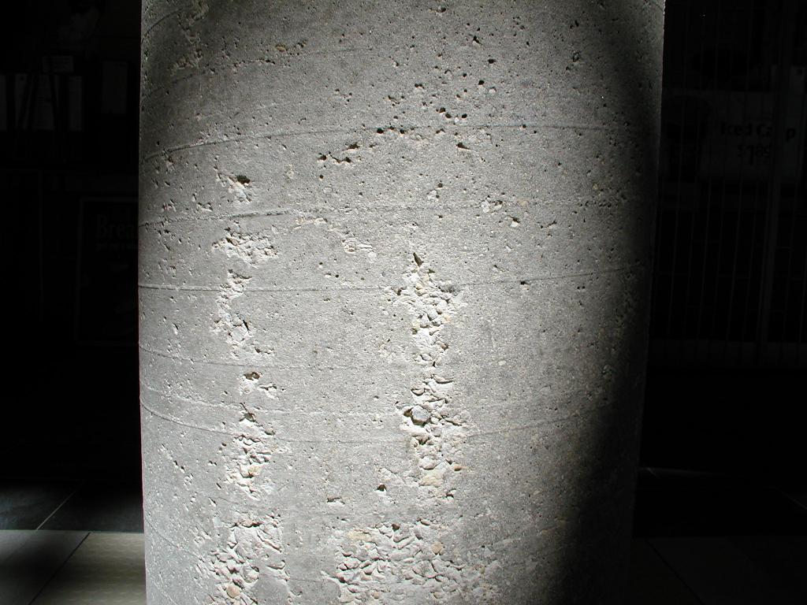Array
th

Background and History
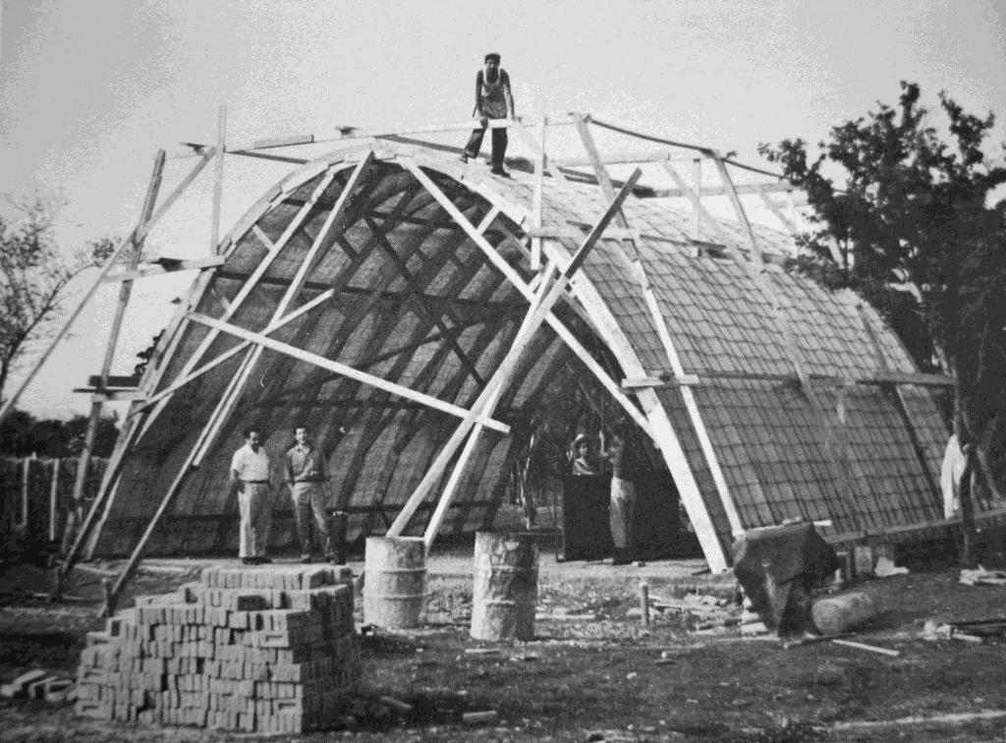Array
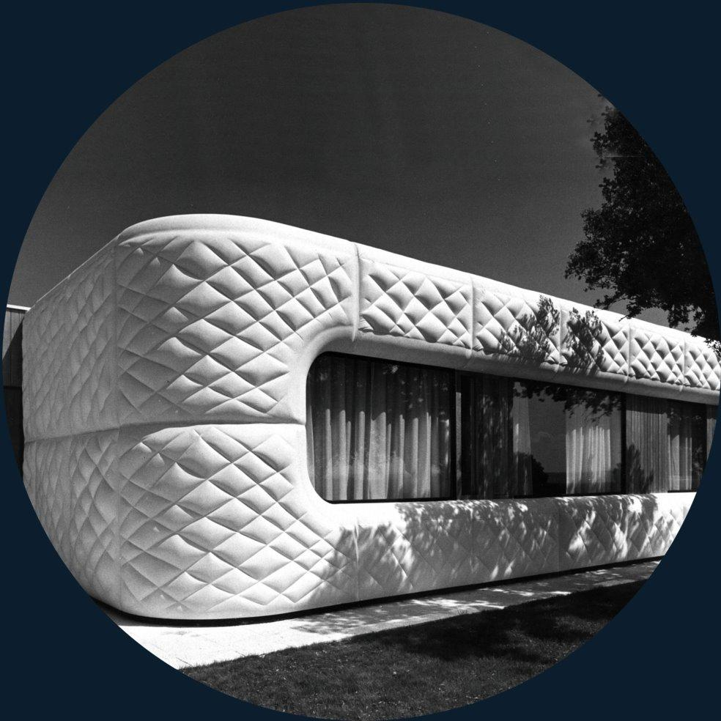Array
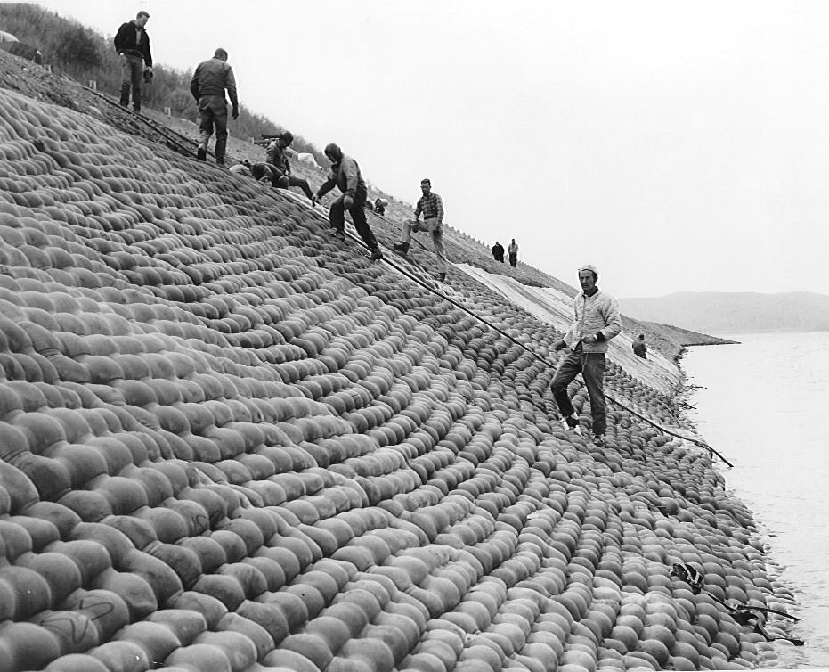Array
www.fab-form.com

Previous Studies Using Permeable Rigid Formwork

Previous Studies Using Fabric Formwork
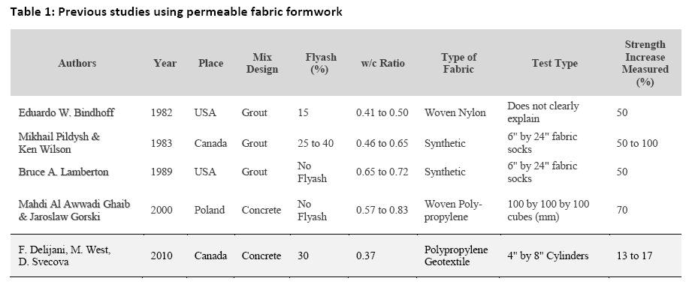Table 1: Previous studies using permeable fabric formwork
-3

Objectives and Scope

- Cement:
- Fine aggregate (Sand):
- Coarse aggregate:

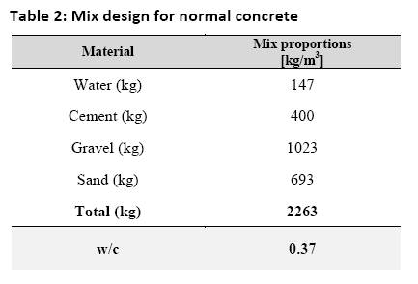Table 2: Mix design for normal concrete
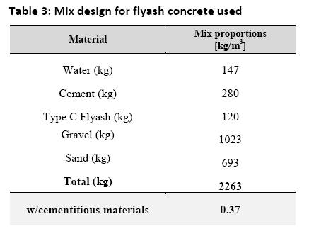Table 3: Mix design for flyash concrete used

See Also
Place text here.

References
Construction and Geotechnical Engineering | Using Synthetic Fabrics.
“”International Conference on Construction and Building Technology 2008
“”First International Conference on Concrete and Development.
Use of Permeable Formwork in Placing and Curing Concrete.
“”In Fabric Formwork
Miguel Fisac.
“”Civil Engineering—ASCE,
“”Concrete International,
“”Arq,
The Centre for Architectural Structures and Technology.http://www.umanitoba.ca/faculties/architecture/cast/
International Society of Fabric Forming.http://www.fabricforming.org/
“”Indian Concrete Journal,
“”Public Roads,
“”Concrete International
“”Concrete International,
“”Cement and Concrete Research,
“”Annual Book of ASTM Standards,
Concrete.
http://storiesofhouses.blogspot.com/http://storiesofhouses.blogspot.com/2006/05/house-in-la-moraleja-madrid-by-miguel.html

External Links
Fabriform
Fab-Form Industries, Ltd.
The Centre for Architectural Structures and Technology (C.A.S.T.)

