BACK TO MAIN TOC

Placing and Handling of Fabric Formed Concrete

Depth of Bleeding Effect

Fabrication of Fabric Molds
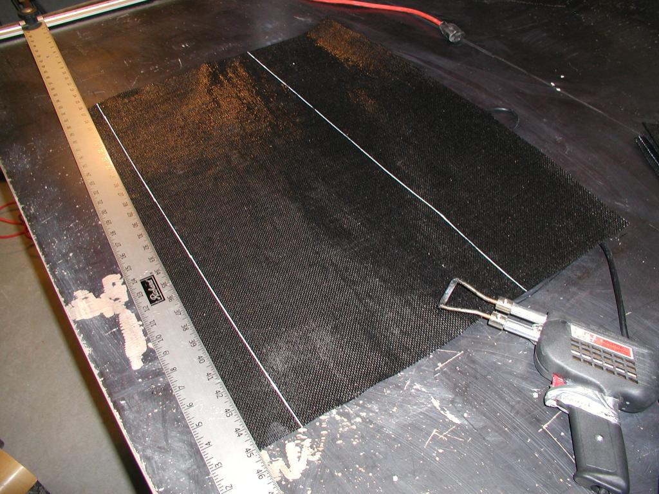Array
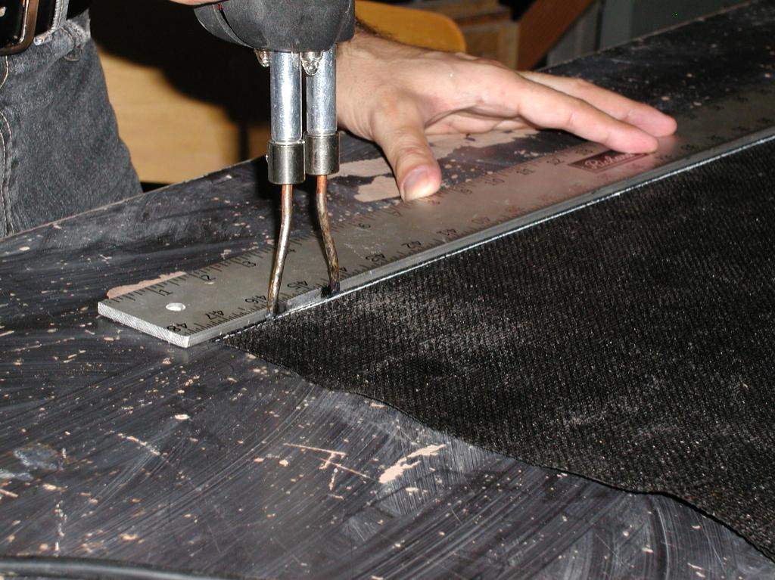Array
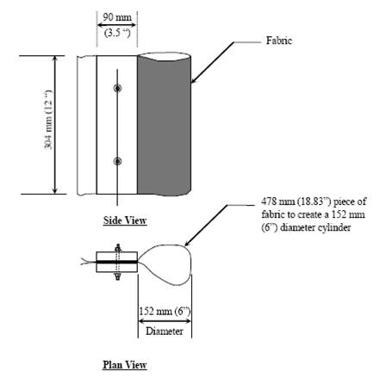Array
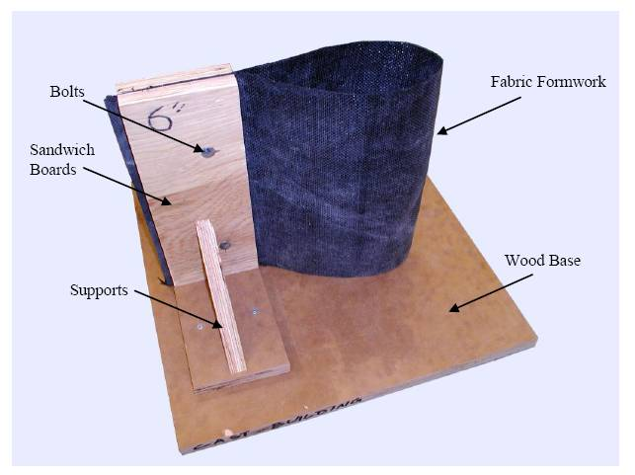Array
<
fs medium>When it was time for specimens to be taken out of their molds, the bolts were removed. Since polyethylene and polypropylene fabrics do not create any adhesion between the fabric and hardened concrete, there is no need for releasing oils and the fabric could be easily stripped off from the surface of the hardened concrete (Figure 24 and Figure 25).</fs>
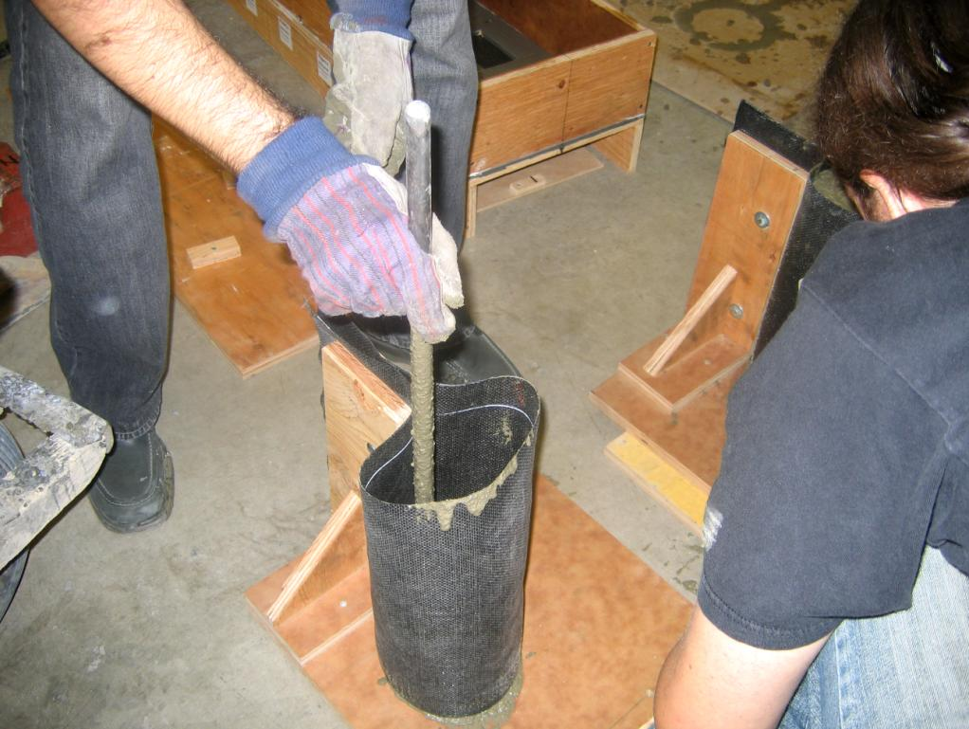Array
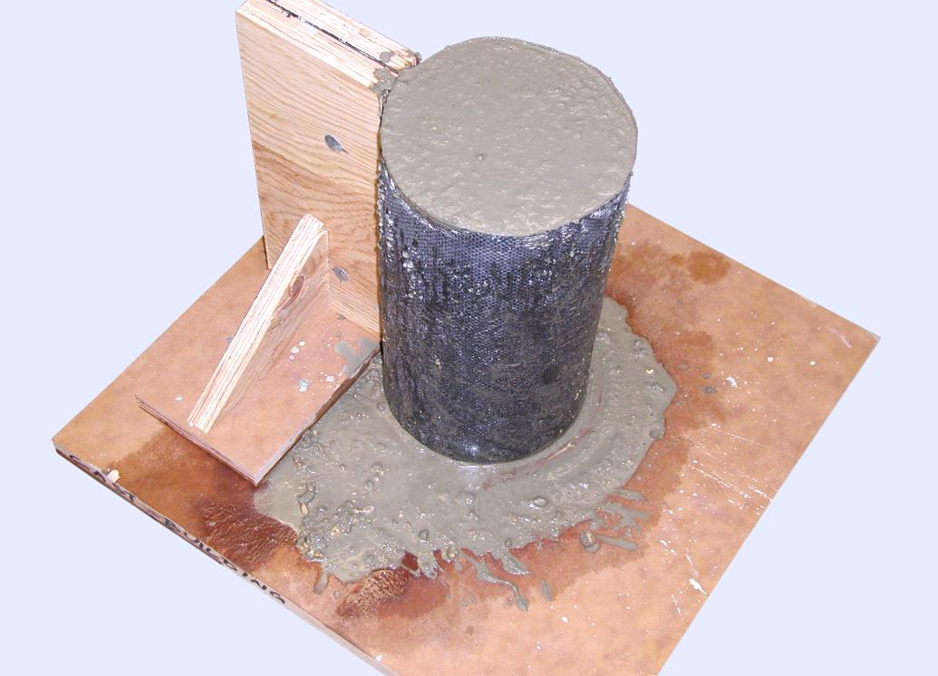Array
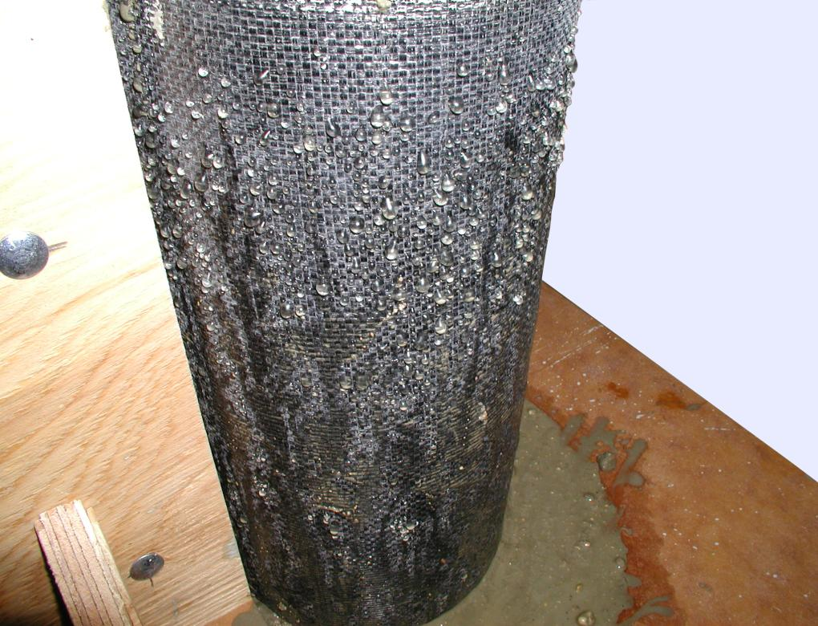Array
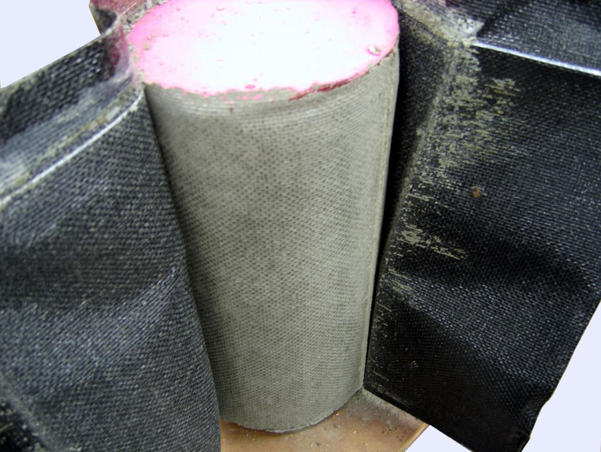Array
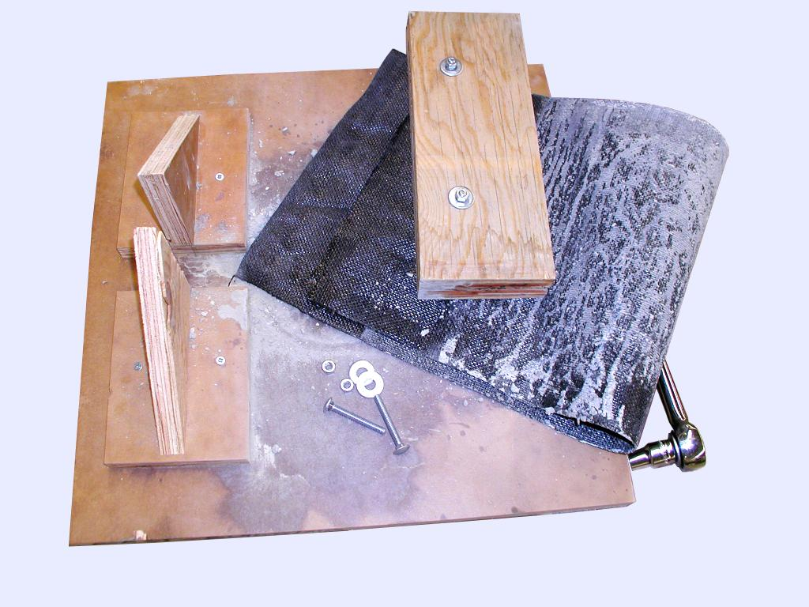Array

Bleeding Tests
Appendix B
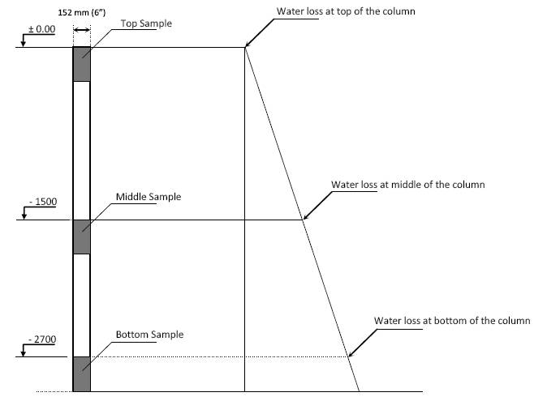Array
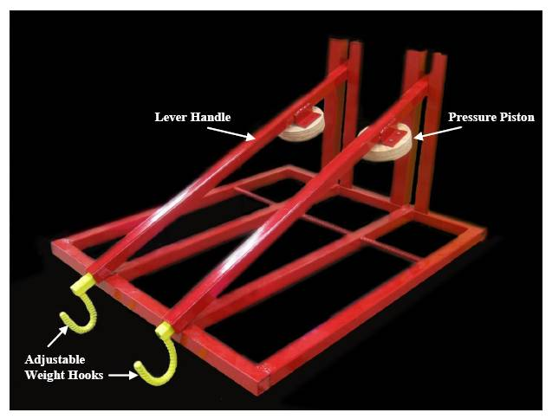Array
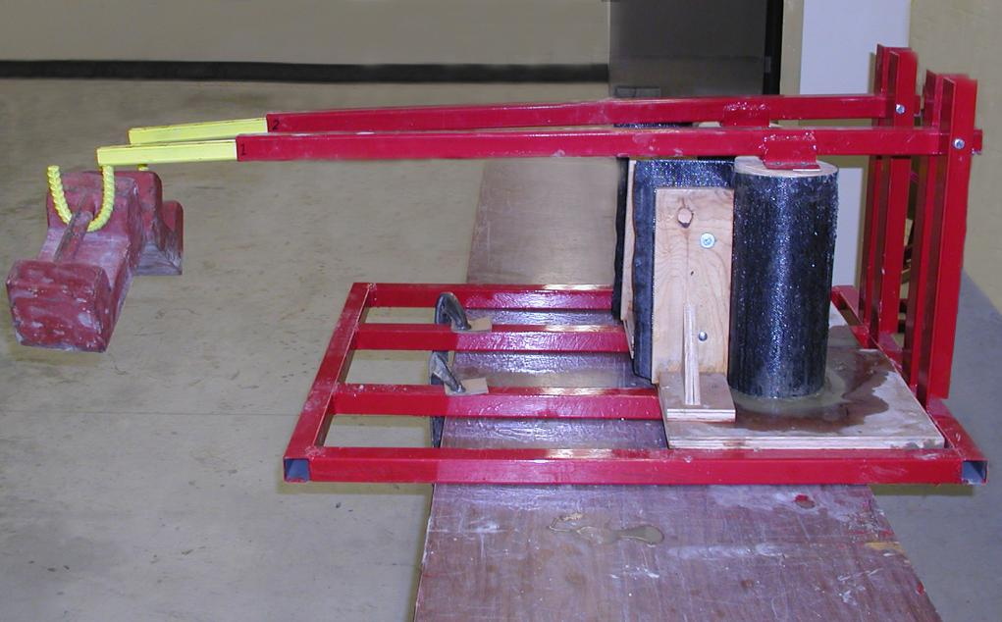Array
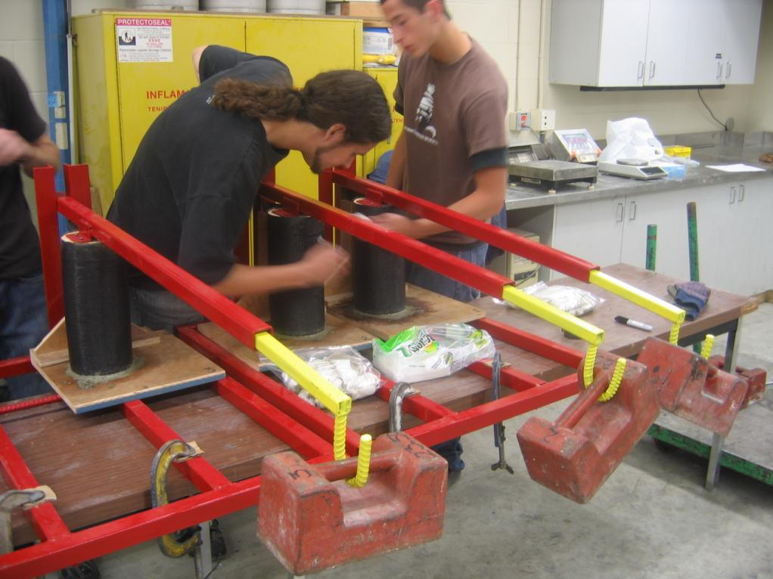Array
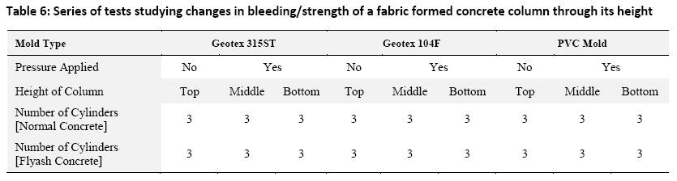Table 6: Series of tests studying changes in bleeding/strength of a fabric formed concrete column through its height

Test Results
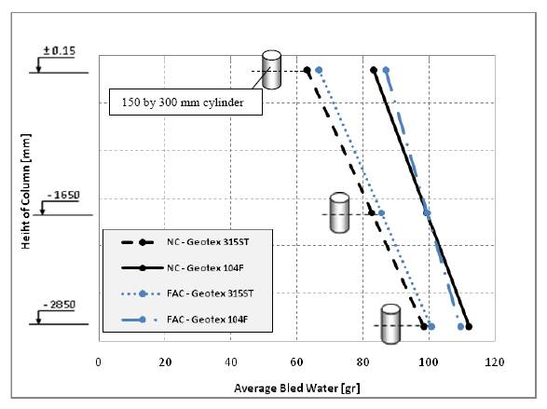Array
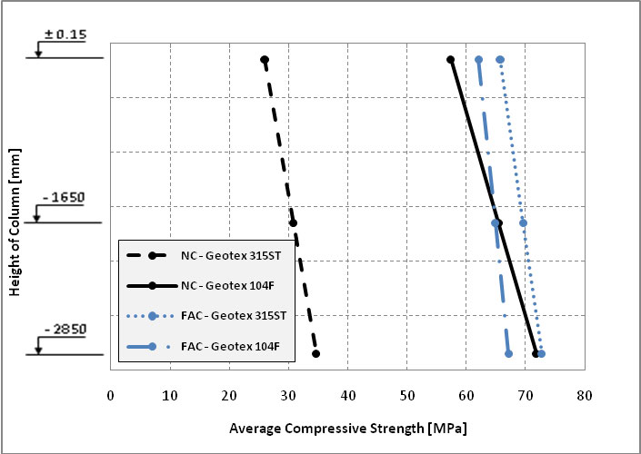Array
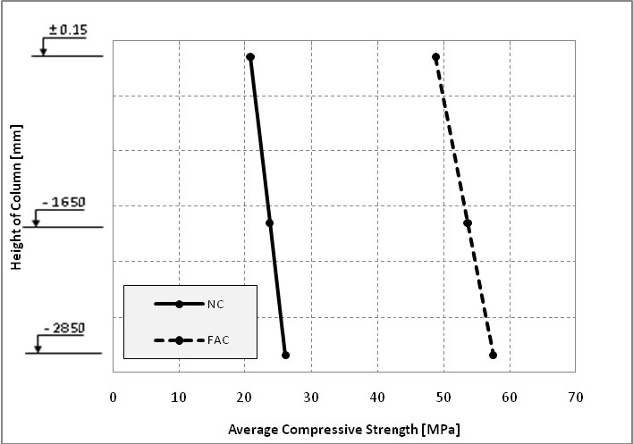Array

Finish Effect of Vibration on Concrete Surface

See Also
Place text here.

References
Use of Permeable Formwork in Placing and Curing Concrete.
Fab-Form Industries Ltd.http://fab-form.com/
Annual Book of ASTM Standards,
“”The Structural Engineer,
Design and Control of Concrete Mixtures.

External Links
Place text here.

