BACK TO MAIN TOC

Strength Tests

Casting and Testing Concrete Cylinders with Fabric Formwork
[Table 2 and Table 3],
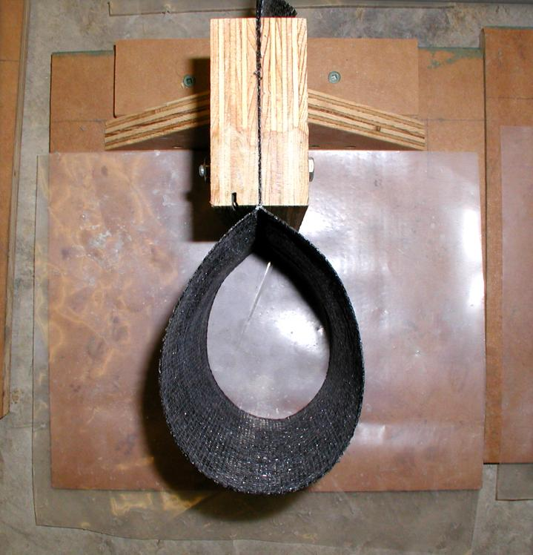Array
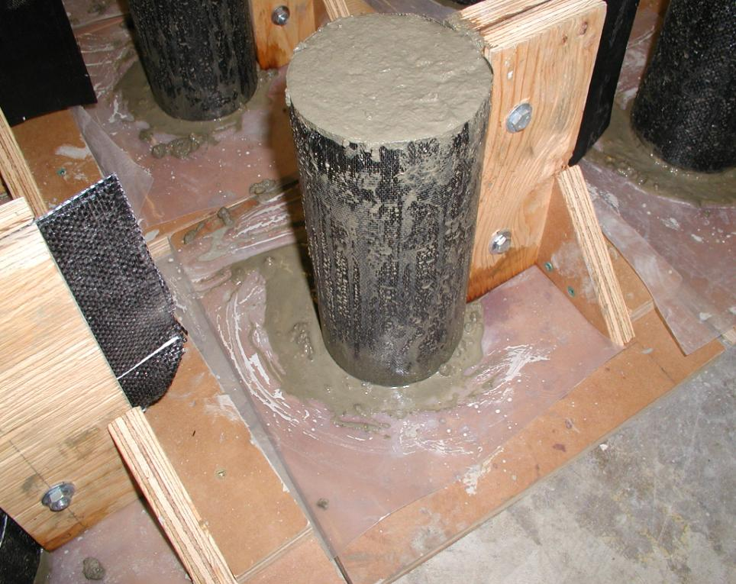Array
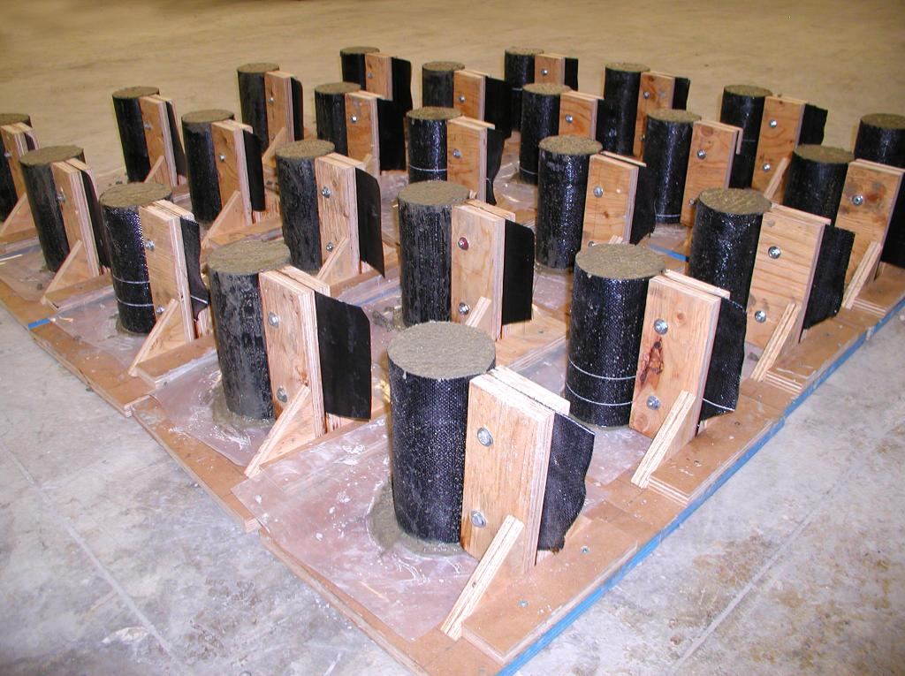Array
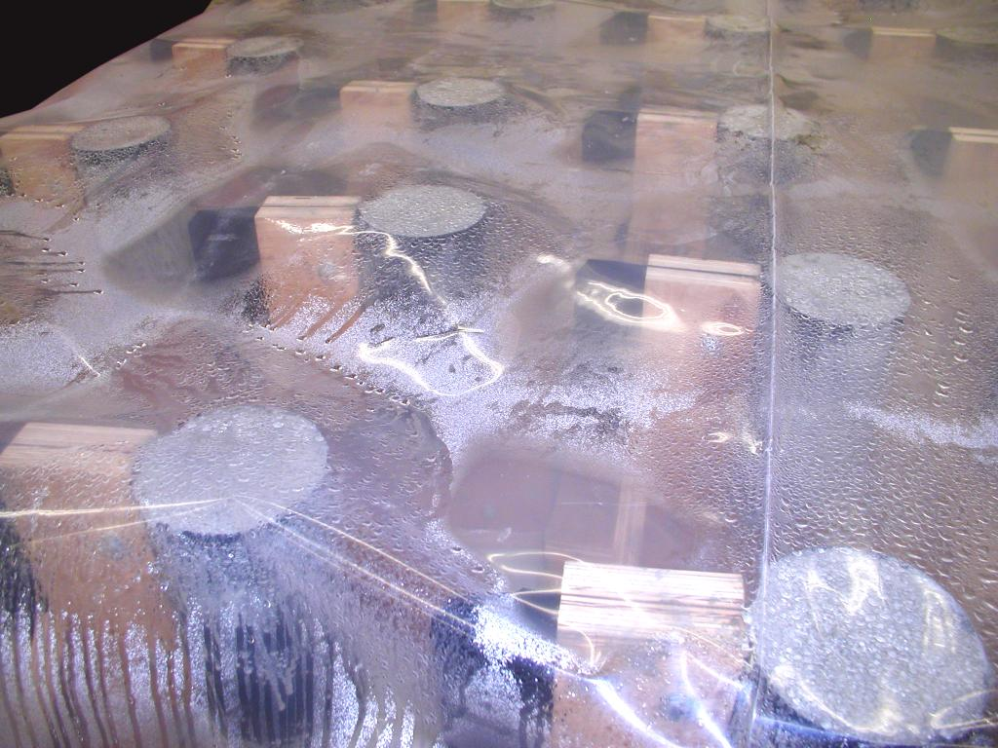Array
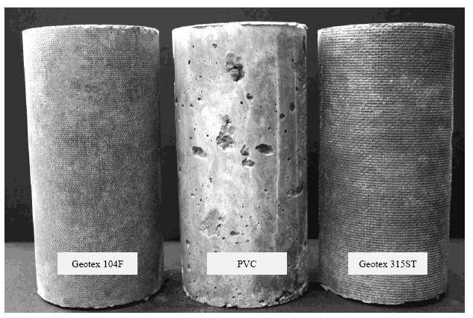Array

Density
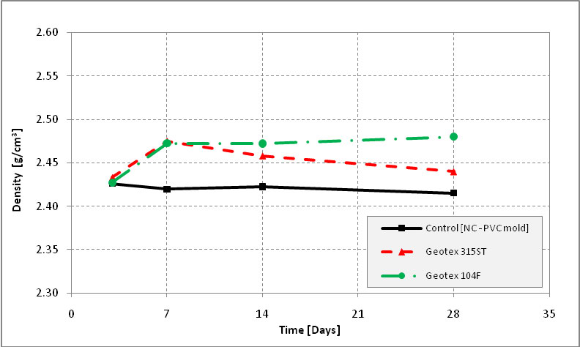Array
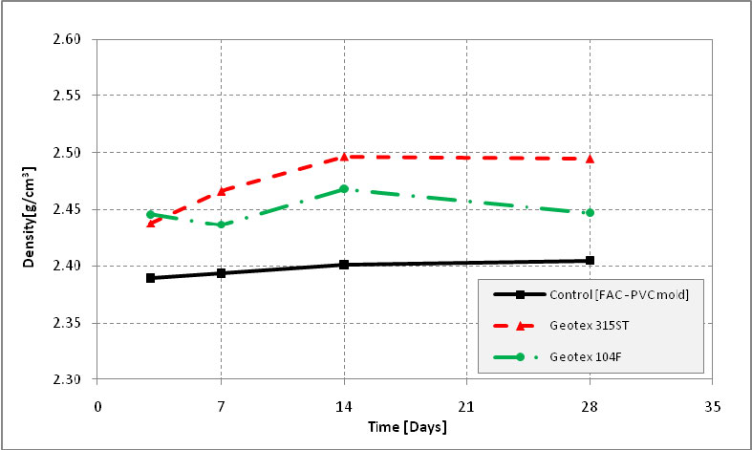Array

Strength Test Results
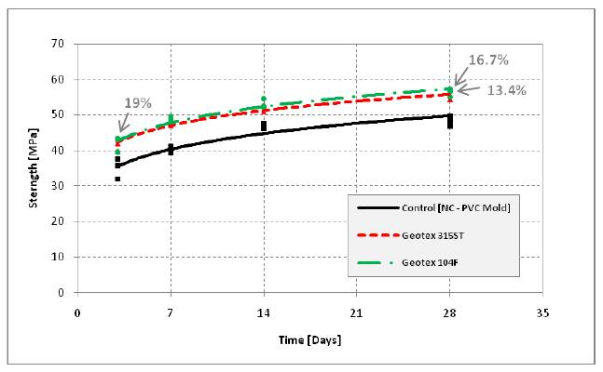Array
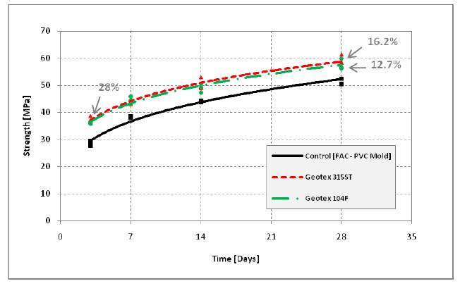Array

See Also
Place text here.

References
Design and Control of Concrete Mixtures.
“”Journal of the American Concrete Institute,

External Links
Place text here.

