ANIMATIONS
Temperature Animation  YouTube Temperature Animation | Temperature Effects using FEA
Form-finding Animation  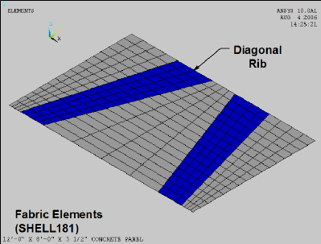Form-finding a Concrete Panel | Form-finding a Concrete Panel using FEA
Cracking Animation  YouTube Cracking Animation | Cyclic Loading using FEA  positive lateral load casenegative lateral load case

